Problem: The Hurdle Race

Dan is playing a video game in which his character competes in a hurdle race by jumping over  hurdles with heights . He can initially jump a maximum height of  units, but he has an unlimited supply of magic beverages that help him jump higher! Each time Dan drinks a magic beverage, the maximum height he can jump during the race increases by  unit.

Given , , and the heights of all the hurdles, find and print the *minimum* number of magic beverages Dan must drink to complete the race.

**Input Format**

The first line contains two space-separated integers describing the respective values of  (the number of hurdles) and  (the maximum height he can jump without consuming any beverages).   
The second line contains  space-separated integers describing the respective values of .

**Constraints**

**Output Format**

Print an integer denoting the *minimum* number of magic beverages Dan must drink to complete the hurdle race.

**Sample Input 0**

5 4

1 6 3 5 2

**Sample Output 0**

2

**Explanation 0**

Dan's character can jump a maximum of  units, but the tallest hurdle has a height of :

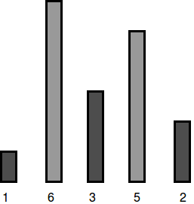

To be able to jump all the hurdles, Dan must drink  magic beverages.

**Sample Input 1**

5 7

2 5 4 5 2

**Sample Output 1**

0

**Explanation 1**

Dan's character can jump a maximum of  units, which is enough to cross all the hurdles:

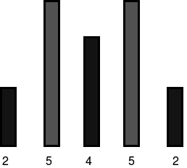

Because he can already jump all the hurdles, Dan needs to drink  magic beverages.

Dan is playing a video game in which his character competes in a hurdle race by jumping over  hurdles with heights . He can initially jump a maximum height of  units, but he has an unlimited supply of magic beverages that help him jump higher! Each time Dan drinks a magic beverage, the maximum height he can jump during the race increases by  unit.

Given , , and the heights of all the hurdles, find and print the *minimum* number of magic beverages Dan must drink to complete the race.

**Input Format**

The first line contains two space-separated integers describing the respective values of  (the number of hurdles) and  (the maximum height he can jump without consuming any beverages).   
The second line contains  space-separated integers describing the respective values of .

**Constraints**

**Output Format**

Print an integer denoting the *minimum* number of magic beverages Dan must drink to complete the hurdle race.

**Sample Input 0**

5 4

1 6 3 5 2

**Sample Output 0**

2

**Explanation 0**

Dan's character can jump a maximum of  units, but the tallest hurdle has a height of :



To be able to jump all the hurdles, Dan must drink  magic beverages.

**Sample Input 1**

5 7

2 5 4 5 2

**Sample Output 1**

0

**Explanation 1**

Dan's character can jump a maximum of  units, which is enough to cross all the hurdles:



Because he can already jump all the hurdles, Dan needs to drink  magic beverages.

*Solution:*

int main()

{

int hurdles, capacity, beverages=0;

cin>> hurdles >>capacity;

int heights[hurdles];

for(int i=0; i<hurdles; i++)

{ cin>> heights[i];

if(capacity<heights[i])

{

beverages+=heights[i]-capacity;

capacity+=heights[i]-capacity;

}

}

cout<<beverages;

return 0;

}

* Anshul Aggarwal